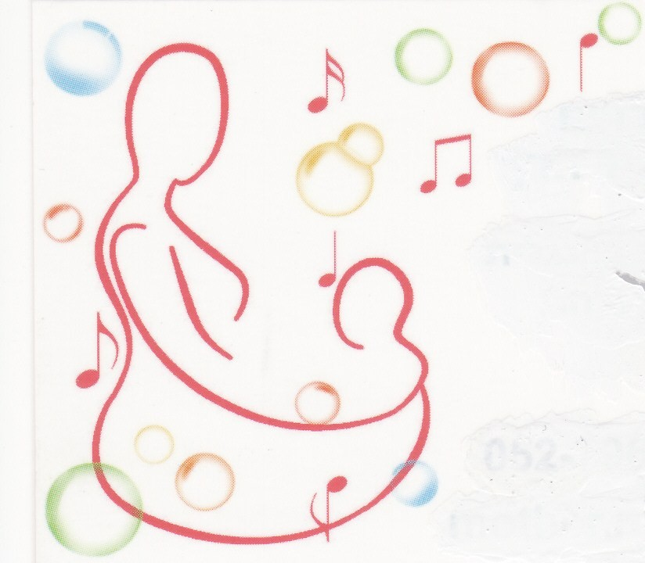
Animal petting activity

You are invited to come and meet snowy the rabbit

Thursday 13 Jan at 10:30
at my house in Vardiya.

The activity is specific and unique for the early years. It gives a chance for children to feed, pet and be close to the animal.

Places are limited so booking in advance is essential.

For more information please contact:

Hila Beck
Mother.n.baby12@gmail.com
M: 052- 7962756
H: 077-532083
