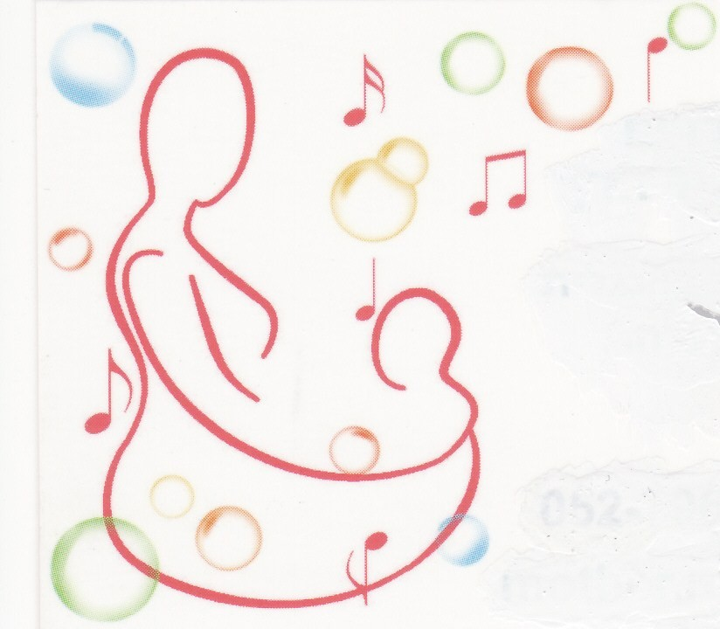
Hila Beck
B.Ed PE, MA Uni of London
Mother.n.baby12@gmail.com
M: 052- 7962756
H: 077-5320831

RHYME TIME IN MOTION FOR MOMS AND TODDLERS

Rhyme time in motion where children are inspired to move and learn

A unique class which incorporates nursery rhymes, movement and lots of fun in English takes place every
Monday @ 10:15 (4 months- 1yrs), 11:00 (in Hebrew)
Tuesday @ 11:00- (English) starting again mid January.
The classes take place at my house in Vardiya.

New special petting activity with animals and other attractions are available. Please see separate leaflet attached for the next available activity in January.

The class is aimed for Moms and babies/toddlers age: 4 months and up in a small setting environment of no more than 8 participants.

The methods and techniques are based on the expertise and experience of a qualified Physical Education and dance teacher who has many years experience in this field in Israel and the UK.

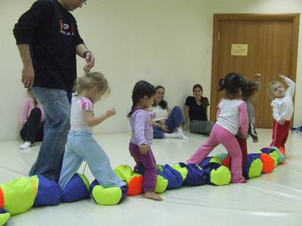
The class puts an emphasis on the interaction between the child and the parent while engaging in songs and rhymes known and familiar to them. Every child in the group will be working according to his or\ her ability and understanding, with the help and guidance of their parent. The child will learn the basic definitions of his body parts, spatial awareness, directions, force and other elements of movement in Early childhood.
All this with constant improvement of their fine and gross motor skills.

So if you feel like joining in with your son or daughter singing ‘row row row your boat’, three little monkeys’, round and round the garden’, ‘Incy Wincy spider’ etc’
Dancing and having fun with them you are more than welcome to give me a call on:

So come and join in the fun!

