
Rates: French Pastry
Bon appétit.
Please place your orders 48h ahead: 054-6652091
Sweet pastries:
Napoleon dessert Mille Feuilles: One portion, 15 NIS; for 10 people, 160 NIS
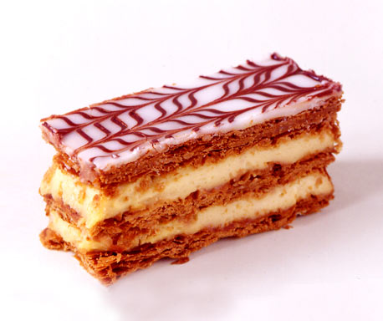

Strawberry Mille Feuilles: One portion, 16 NIS; for 10 people, 180 NIS

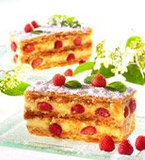

Chocolate or coffee Religieuse: One unit, 9 NIS.
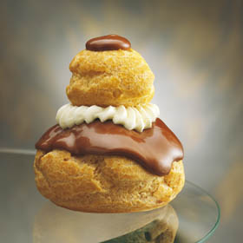

Cream Choux: One unit, 6 NIS
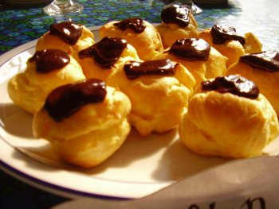

Chocolate or coffee Éclair: One unit, 7 NIS
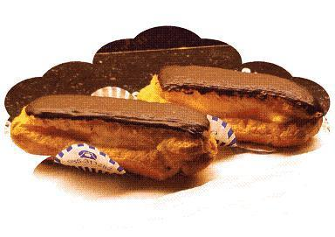

Whipped cream Choux (Chantilly): One unit, 5 NIS.
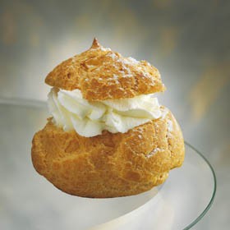

Apricot Tartlets: One unit, 15 NIS; for 10 people, 150 NIS.
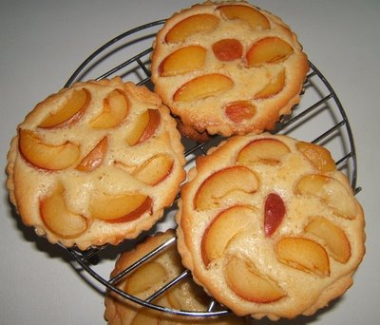

Apple Tartlets: One unit, 16 NIS, for 10 people, 160 NIS.
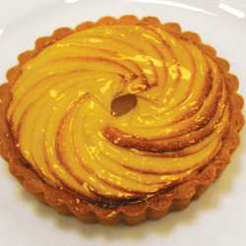

Strawberry Tartelettes: One unit, 17 NIS, for 10 people, 170 NIS.
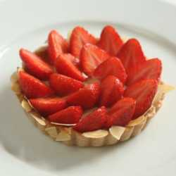

Banana and kiwi Tartelettes: One unit, 17 NIS, for 10 people, 170 NIS
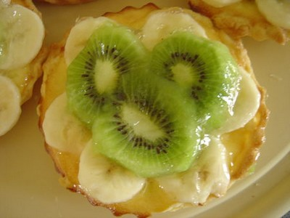

Flan Tarte: One unit, 12 NIS; for 10 people, 150 NIS.

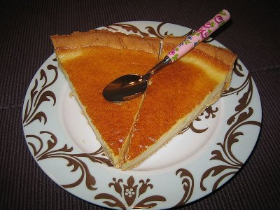

Lemon Tartelette: One unit, 15 NIS; for 10 people, 150 NIS.
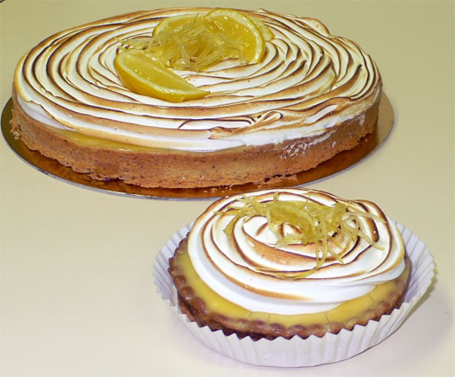

Chocolate Tartelette: One unit, 17 NIS, for 10 people, 170 NIS
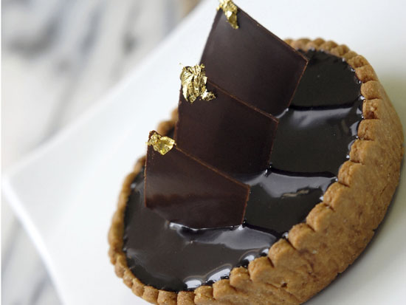
.

All our tartes and tartelettes are prepared with pastry cream,
crème pâtissière.
All fruit pastries are prepared according to the season

Brownies with custard: One unit, 12 NIS: for 10 people, 120 NIS.

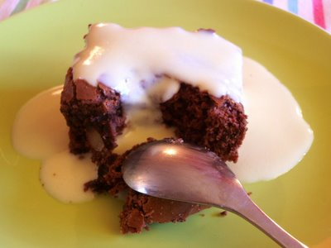

Crème brulée: One unit, 15 NIS.
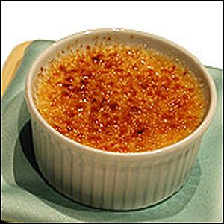

Rum baba, Baba au rhum : One unit, 14 NIS.
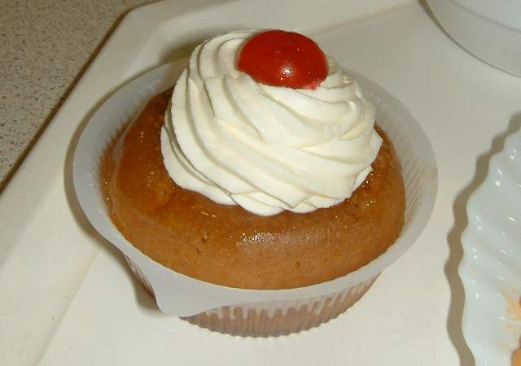

Tropézienne : one portion 14 NIS; for 10 people 140 NIS.
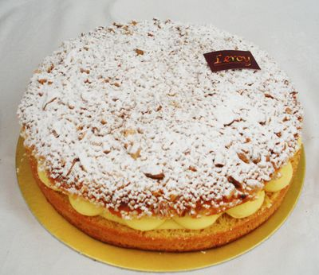

Lemon or chocolate Madeleine : 23 NIS for 9 units

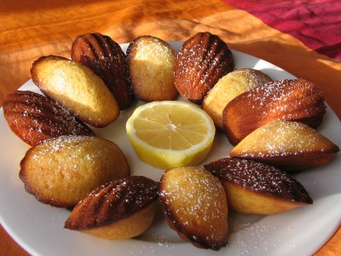

Savory pastries:
Aperitif Feuilletés: pizza, anchovy feuilletés, cheese salty pastries, salmon feuilletés etc… 34 NIS for 500 grams.
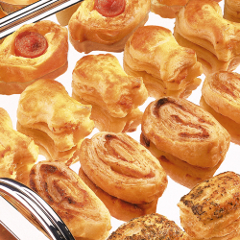

Leak Tarte: One unit, 12 NIS; for 8 people, 90 NIS.

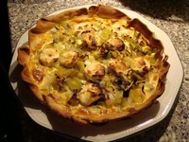
Salmon Tartelette: One unit, 15 NIS, for 8 people, 120 NIS.

